industry-specific intelligent fire management system

D. MUKESH KANNA *(210219106026), S. SIVA (210219106034), K. HARISH (210219106015), S. SELVAKUMAR (210219106033), M.balakrishnan(210219106006)*

Department of Electronics Communication Engineering, Apollo Engineering College, Poonamallee, Chennai.

|  |  |
| --- | --- |
| TEAM ID | PNT2022TMID36766 |
| PROJECT NAME | INDUSTRY- SPECIFIC INTELLIGENT FIRE MANAGEMENT SYSTEM |
| TEAM LEADER | D. MUKESH KANNA |
| TEAM MEMBER 1 | S. SIVA |
| TEAM MEMBER 2 | K. HARISH |
| TEAM MEMBER 3 | S. SELVAKUMAR |
| TEAM MEMBER 4 | M. BALAKRISHNAN |

**1. INTRODUCTION**

**1.1 PROJECT OVERVIEW**

* An intelligent fire alarm system is specifically designed to provide advantages such as identification of the fire location, locate any fault in the alarm system wiring, and ensure easier maintenance. Moreover, these modern intelligent fire alarm systems are more sensitive as compared to the classic models and are competent to detect false alarms.
* Intelligent fire alarm systems utilize smart devices along with wireless technology to protect & manage buildings or workstations through a remote control panel (essentially a mobile application that can be downloaded, installed, and accessed from a smartphone). Intelligent fire alarm systems are usually available in three designs: addressable, conventional, and wireless.

**1.2 PURPOSE**

The primary purpose of fire alarm system is to provide an early warning of fire so that people can be evacuated & immediate action can be taken to stop or eliminate of the fire effect as soon as possible. Alarm can be triggered by using detectors or by manual call point (Remotely). To alert/evacuate the occupants siren are used. With the Intelligent Building of the rapid development of technology applications, commercial fire alarm market demand growth, the key is to use the bus system intelligent distributed computer system fire alarm system.

**2. LITERATURE SURVEY**

**2.1 EXISTING PROBLEM**

This Project focuses on Detection on fire management using smart sensors iot to ensure the safe supply of avoiding gas leakage and the quality should be monitored in real time as per alarm for that purpose new approach IOT (Internet of Things) based on fire sensor equipments monitoring has been proposed. This system consists some sensors.

* 1. **REFERENCES**
* 1. National Interagency Fire Center. [2012a]. Incident management situation report.  Date accessed: July 13, 2012
* 2. Britton. [2010]. Risk factors for injury among federal wildland firefighters in the United States [dissertation]. Athens, Ohio: University of Ohio, College of Public Health.
  1. **PROBLEM STATEMENT DEFINITION**

**It must be able to detect fires at all locations, residents must be able to activate it from convenient locations themselves, and it must alert residents in all portions of the house**. This system should reduce the cost of fire-insurance protection as well as provide security for the homeowner.

**3. IDEATION & PROPOSED SOLUTION**

**3.1 EMPATHY MAP CANVAS**

An Empathy map is a collaborative tool teams can use to gain a precaution of fire incase of accident for customers. Much like a user persona, an empathy map can represent a group of users, such as a customer segment. Our empathy map canvas is shown as fire management system.

The ***Thinks***quadrant captures what the user is thinking throughout the experience. It is possible to have the same content in both *Says* and *Thinks*. However, pay special attention to what users think, but may not be willing to vocalize. Try to understand why they are reluctant to share — are they unsure, self-conscious, polite, or afraid to tell others something

* *“This is really annoying.”*
* *“Am I dumb for not understanding this*

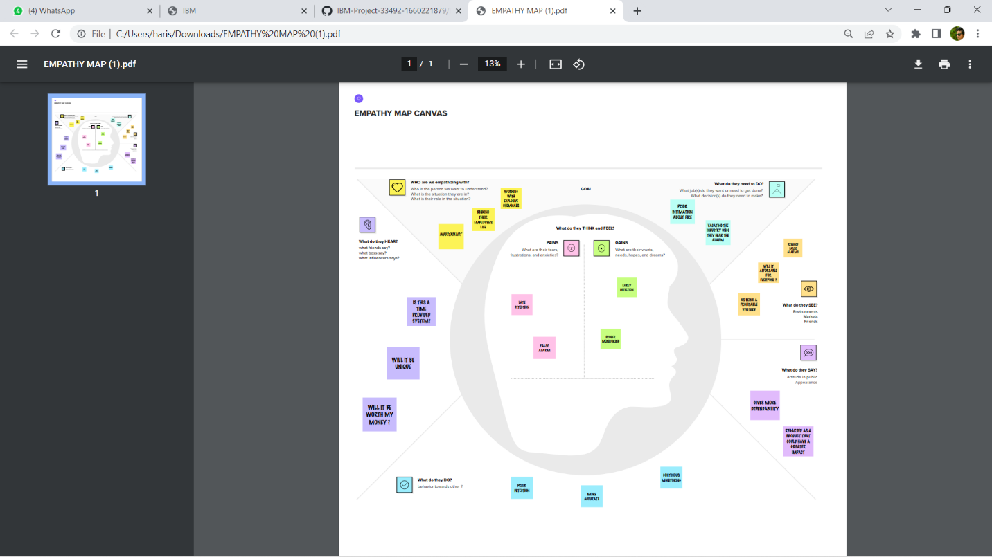

**3.2 IDEATION & BRAINSTORMING**

Ideation refers to the hole crreative process of coming up with and communicating new ideas.It can take many different forms,from coming up with a totally new idea to combining multiple existing ideas to create a new process or organizational system.Ideation is similar to a pratice known as brainstorming.

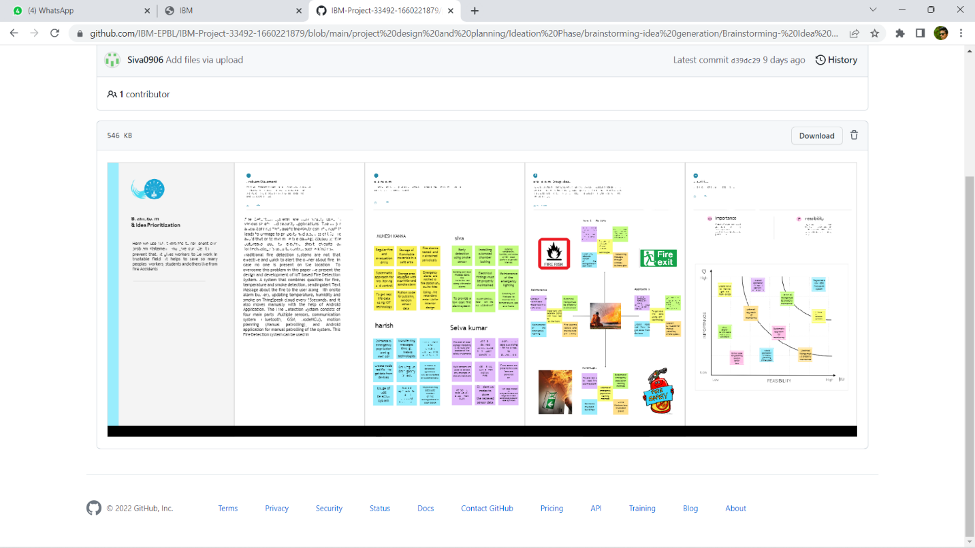

**3.3 PROPOSED SOLUTION**

Proposed Solution means the technical solution to be provide by the implementation agency in response to the requirements and the objectives of the project. he following information may be useful to you in completing this portion of your team’s work. Skim this section, then refer back to it as necessary.

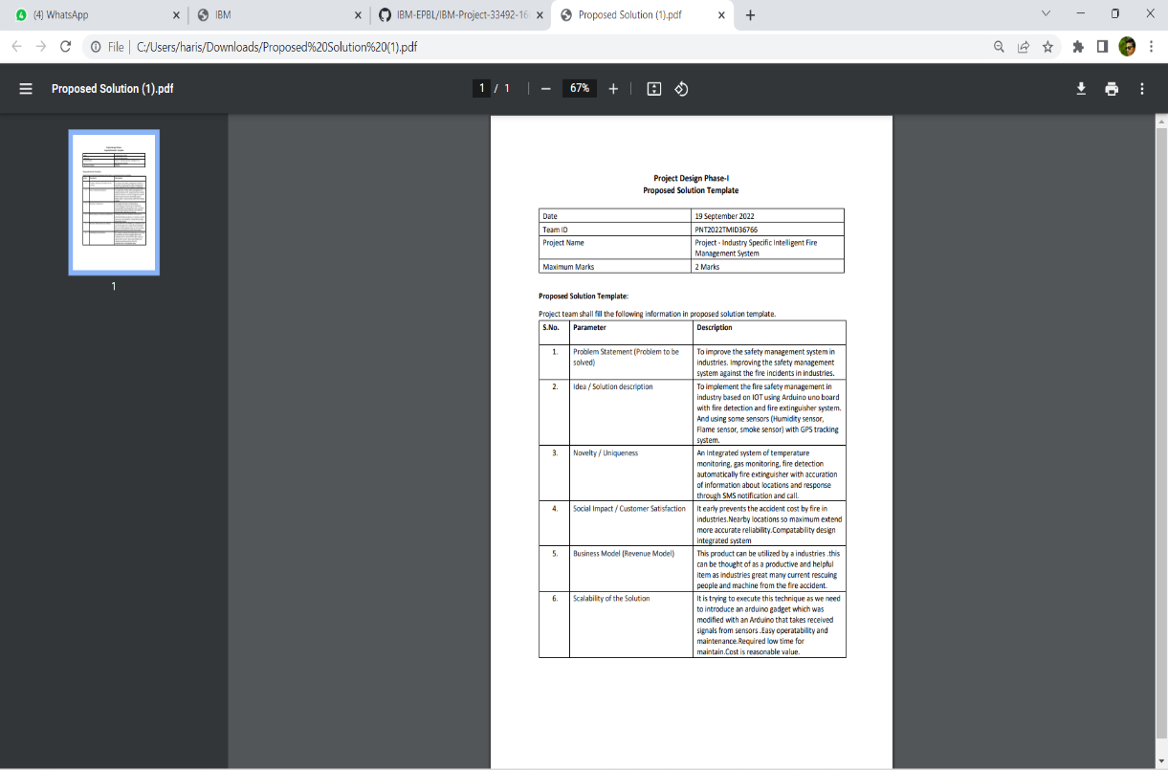

**3.4 PROBLEM SOLUTION FIT**

Problem solving is the act of defining a problem; determining the cause of the problem; identifying, prioritizing, and selecting alternatives for a solution; and implementing a solution. In order to effectively manage and run a successful organization, leadership must guide their employees and develop problem-solving techniques. Finding a suitable solution for issues can be accomplished by following the basic four-step problem-solving process and methodology outlined below.

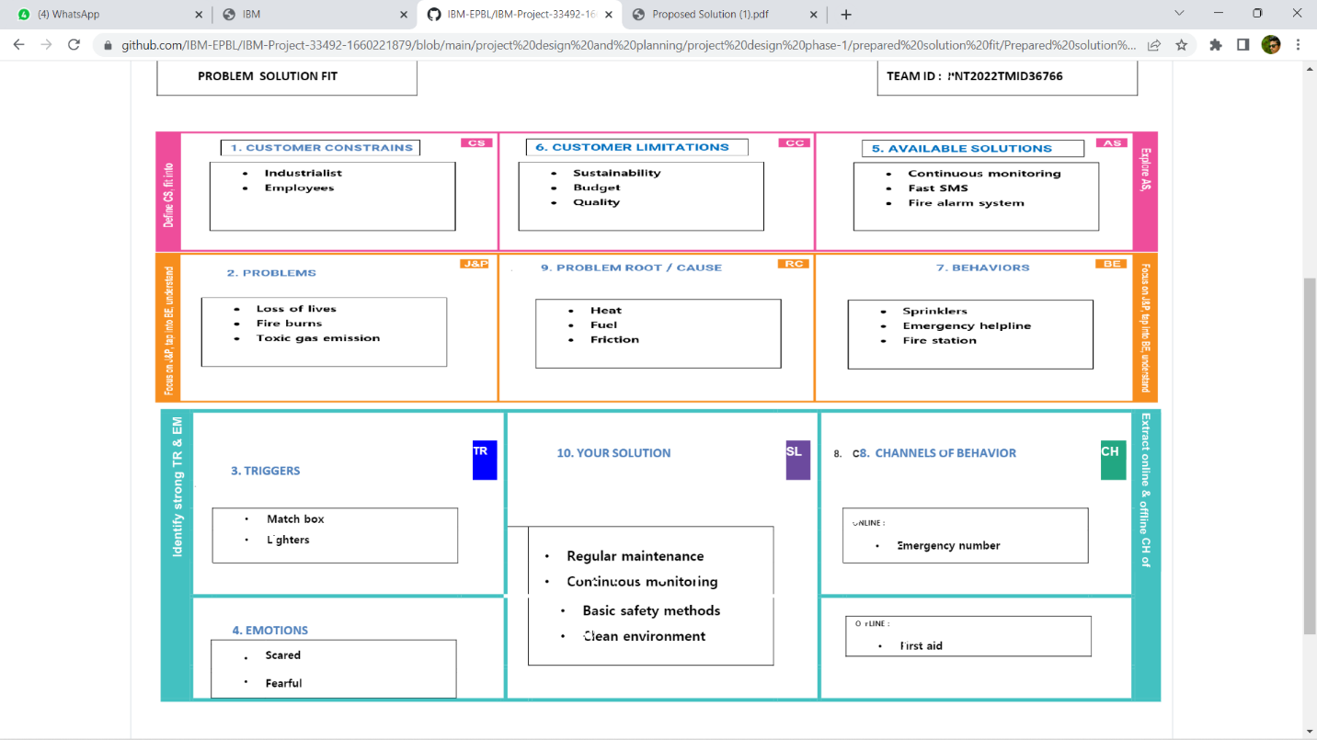

**4. REQUIREMENT ANALYSIS**

Requirement analysis also called as requirement engineering is the process of determining user expectation for a new or modified product. These features are called requirement must be qualifiable relevant and detailed. Its classified as two major type. They are;

**4.1 FUNCTIONAL REQUIREMENT**

**Functional requirement define product must do, what features and functions.**

**4.2 NON-FUNCTIONAL REQUIREMENT**

**NFR generally stated, often contracdictory, difficult to enforce during development and evaluate for the customer prior to delivery.**

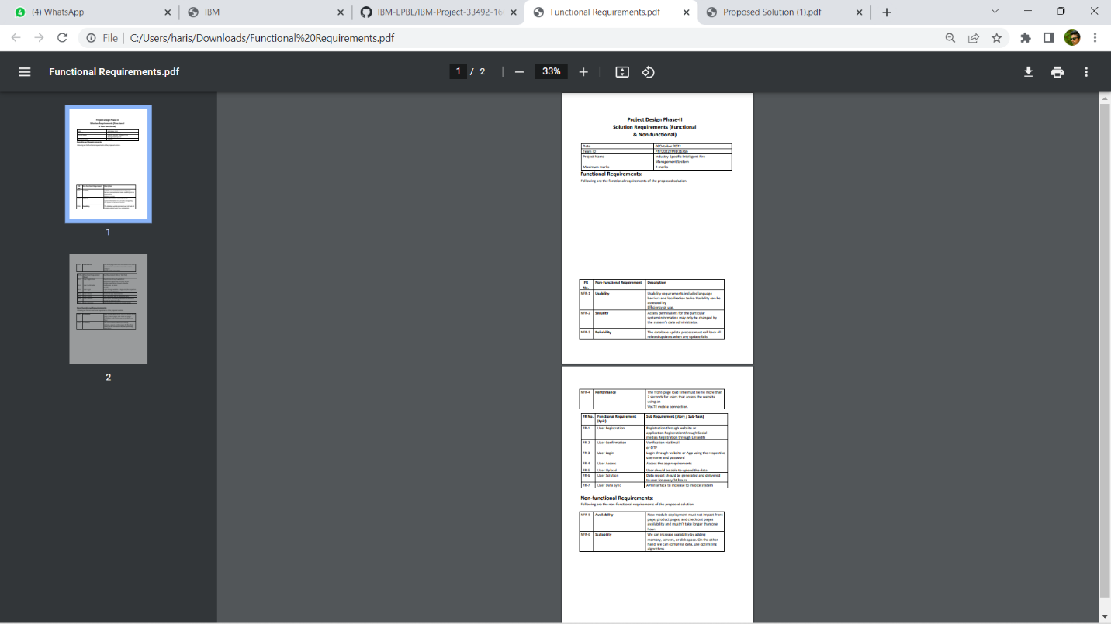

**5. PROJECT DESIGN**

**5.1 DATA FLOW DIAGRAM**

Data flow diagram is a way of representing a flow of data through a processer or a system. DFD also provide information about the input and output of each entity and the process itself. A data flow diagram as no control flow they are no decision rules and no loops.

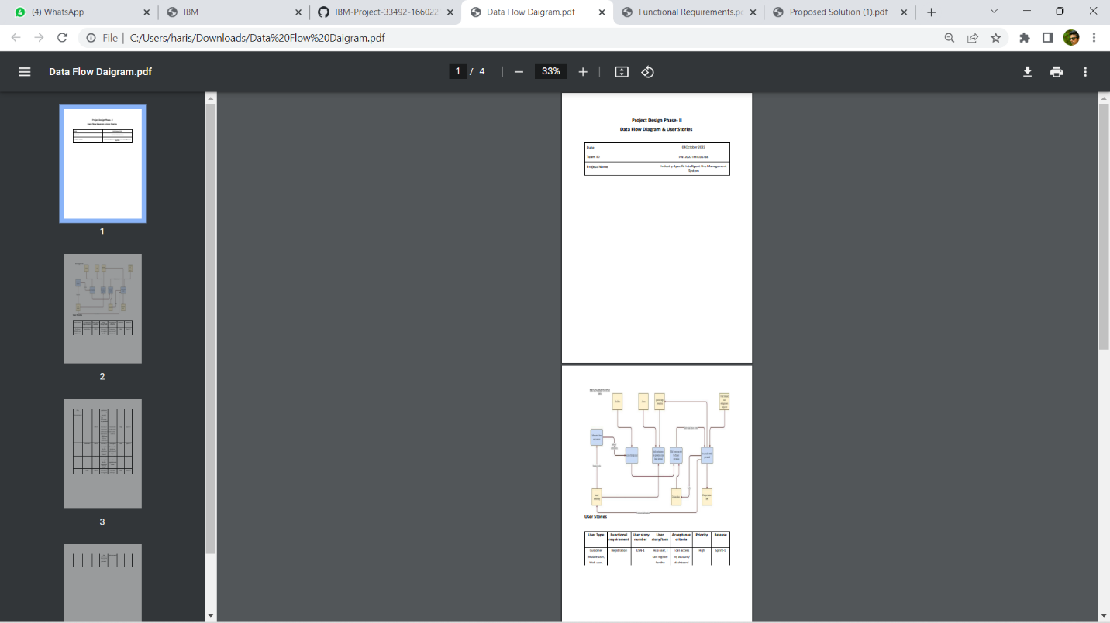

**5.2 SOLUTION & TECHNICAL ARCHITECTURE**

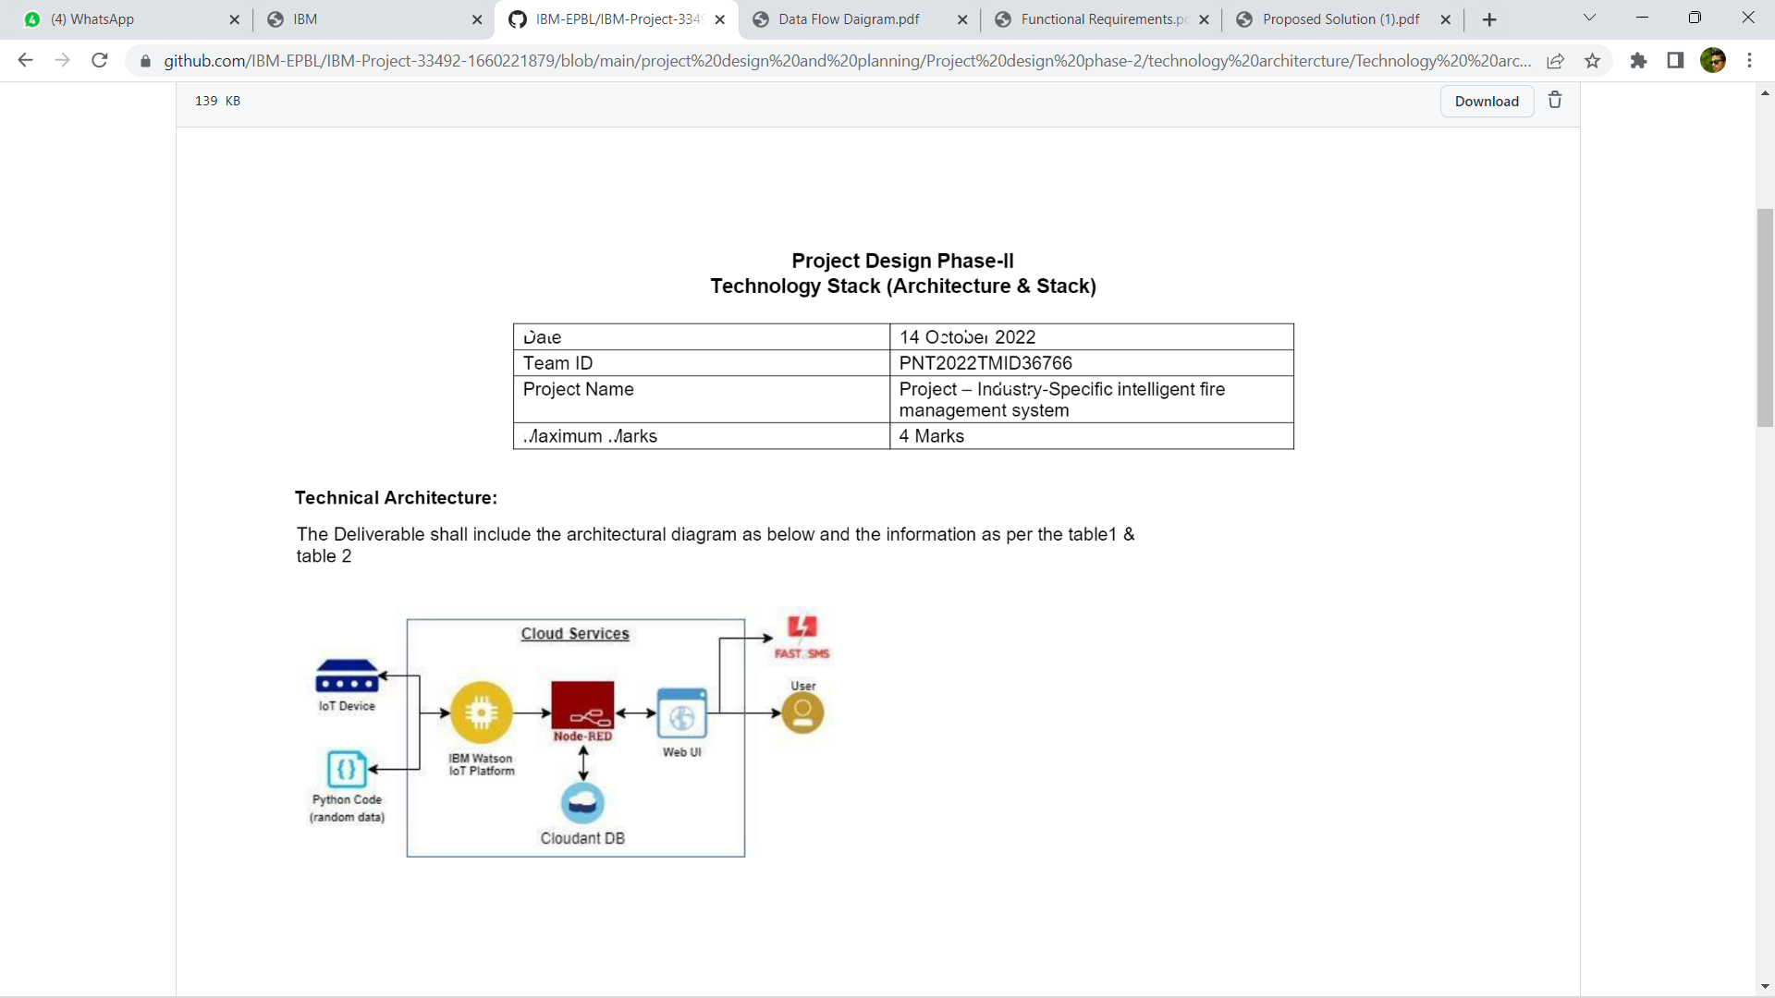

A Solution architecture is an architectural description of a specific solution. SAs combine guidance from different enterprise architectural viewpoints (business, information and technical) as well as from the enterprise solution architecture (ESA).

**5.3 USER STORIES**

(1)Information collection module In order to realize the real-time collection and update of the information and ensure the accuracy of the information, the existing internet of things equipment such as monitoring, smoke feeling, fire control sign and so on are used to collect the field information and efficiently understand the situation on the spot. (2)Model module The BIM model of the building is established by using BIM technology. The model includes the information of all the components in the building, the information of water, electricity and gas and all the information of fire extinguishing equipment, thus which can provide data support for indoor escape and rescue of building firefighting. (3)Intelligent processing module The intelligent processing module can automatically plan the rescue path, rescue tools, indoor escape path, and modify the contents of fire protection sign by synthetically processing the data of the information collection module and the model module. (4)Decision module The rescue center reads the information on the equipment and models of internet of things, and other information through the decision module, and issues the emergency evacuation command, at the same time, which chooses the outdoor rescue routes and rescue tools, and sends rescue orders to the rescue teams. (5)Information feedback module After the decision is made, the information feedback module automatically releases the best escape route to the survivors, and indicates the location of the fire rescue tools nearby, besides provides the best rescue route, rescue ways, rescue tools and other information to the rescuers, and relieves the alarm in time after the rescuing. (6)Escape terminal APP module

We offer design, testing and installation of VESDA fire alarm and warning systems to clients who have a zero tolerance for incidences policy. These are typically mission critical facilities like hospitals, clean rooms, telecommunication hubs, high-rise building, laboratories, data centers, museums and airports. The defining feature of such facilities is either a large number of occupants, which makes evacuation difficult; or the presence of expensive property, like high tech equipment or art collections.

We offer design, testing and installation of VESDA fire alarm and warning systems to clients who have a zero tolerance for incidences policy. These are typically mission critical facilities like hospitals, clean rooms, telecommunication hubs, high-**6. PROJECT PLANNING & SCHEDULING**

**6.1 SPRINT PLANNING & ESTIMATION**

Sprint planning is an event in scrum that kicks of the sprint. The purpose of sprint planning is to define what we can deliver in the sprint and how that work will be achieved. Sprint planning is done in collaboration with the whole scrum team

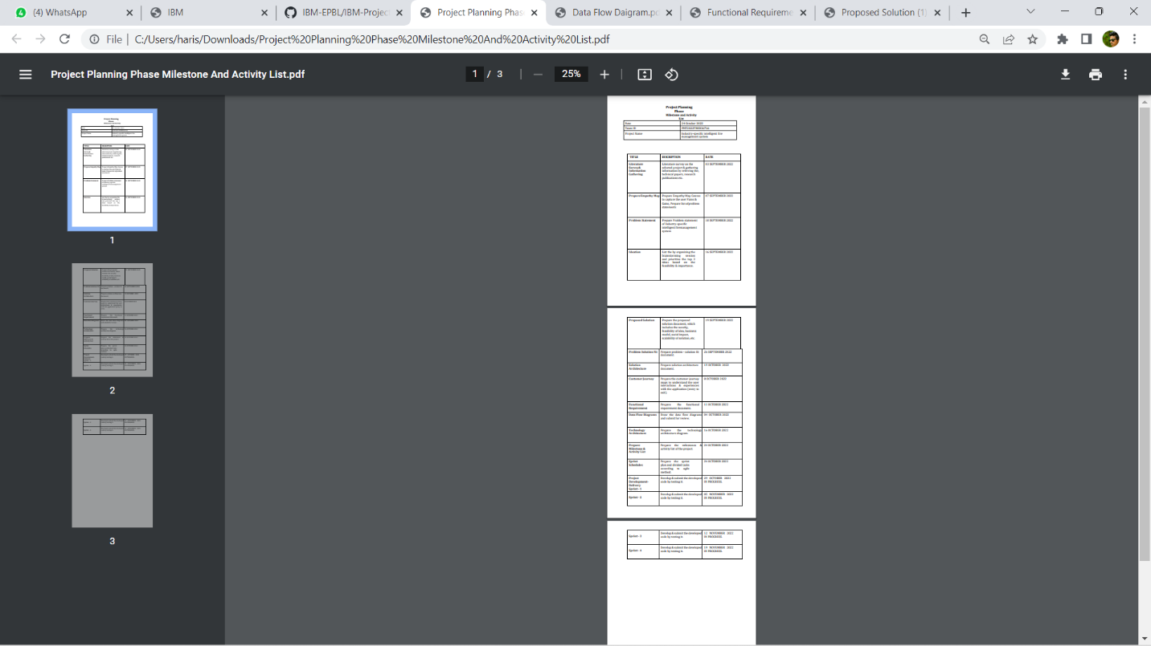.

**6.2 SPRINT DELIVERY SCHEDULE**

The deliverables of the sprint are not as predictable as they are for the other project. Sprint participance have produced sketches and drawing, writing, photograph, comic, strip, video and fully coded working prototypes

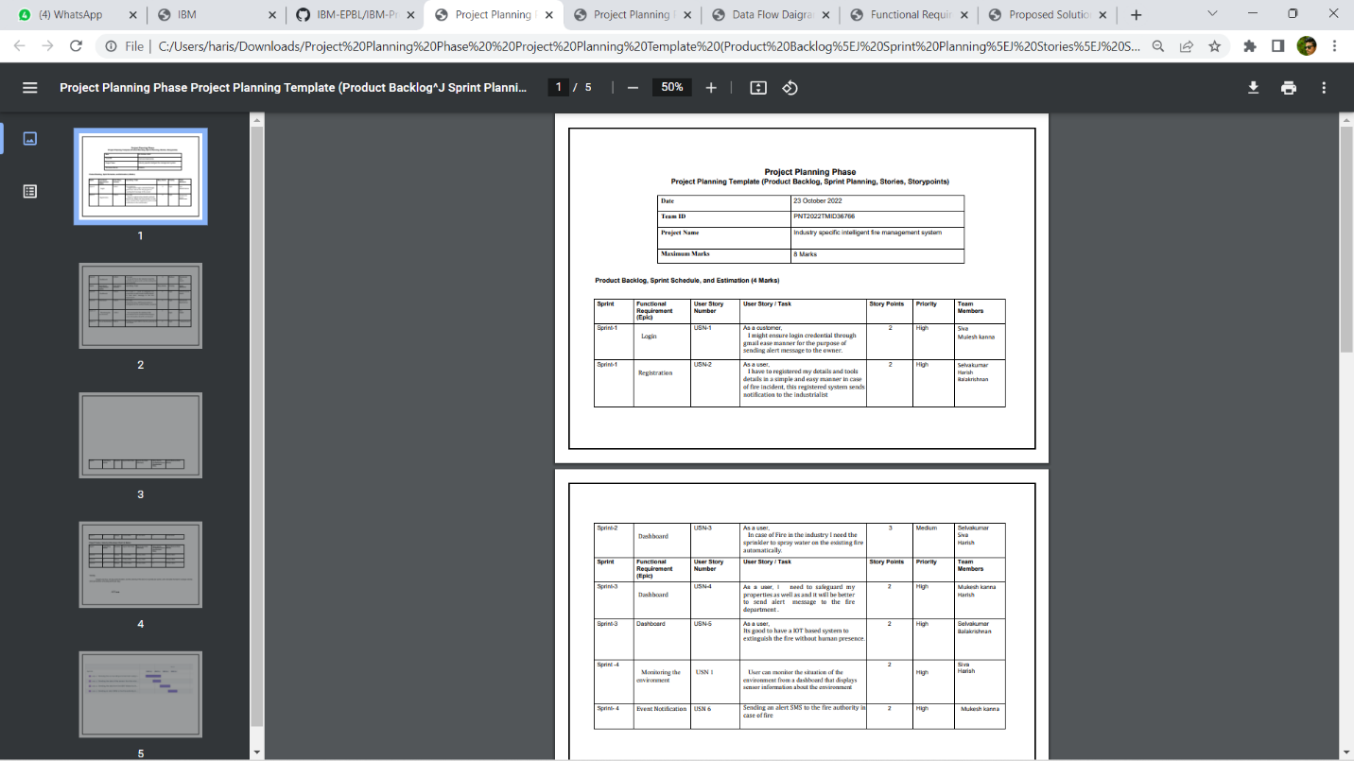

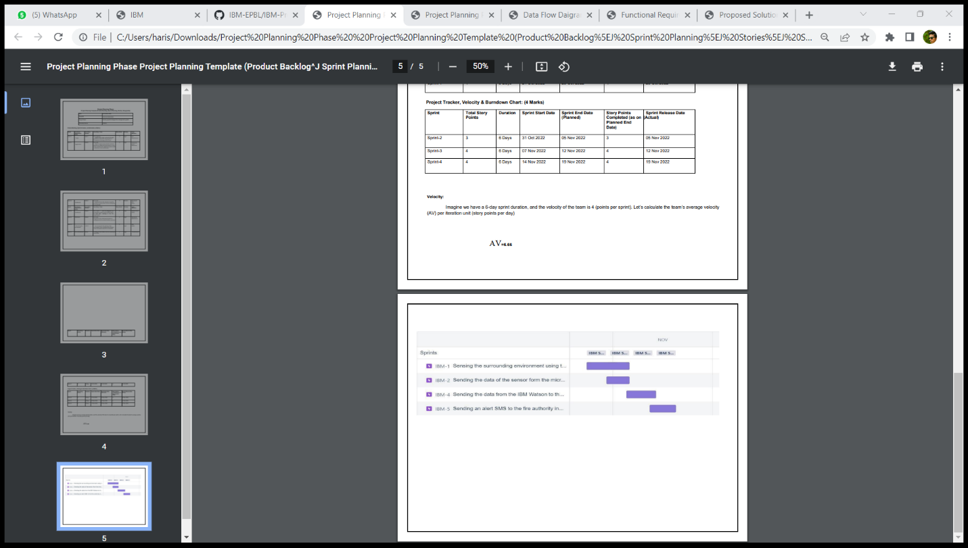

The programmer designs the model to mon

itoring and control river water quality

The

programmer designs the model to monitoring and control river water quality

**7. CODING & SOLUTIONING (Explain the features added in the project along with code)**

**7.1Feature 1**

}

#includ#include <WiFi.h>//library for wifi

e <PubSubClient.h>//library for MQtt

#include "DHT.h"// Library for dht11

#define DHTPIN 15 // what pin we're connected to

#define DHTTYPE DHT22 // define type of sensor DHT 11

#define LED 2

DHT dht (DHTPIN, DHTTYPE);// creating the instance by passing pin and typr of dht connected

void callback(char* subscribetopic, byte* payload, unsigned int

payloadLength);

//-------credentials of IBM Accounts------

#define ORG "afrxny"//IBM ORGANITION ID

#define DEVICE_TYPE "sprint1"//Device type mentioned in ibm watson IOT Platform

#define DEVICE_ID "9878"//Device ID mentioned in ibm watson IOT Platform

#define TOKEN "utxQdRh7jNpa+vbh(U" //Token

String data3; float t;

//-------- Customise the above values --------

char server[] = ORG ".messaging.internetofthings.ibmcloud.com";// Server Name

char publishTopic[] = "iot-2/evt/Data/fmt/json";// topic name and type of event perform and format in which data to be send

char subscribetopic[] = "iot-2/cmd/command/fmt/String";// cmd REPRESENT

command type AND COMMAND IS TEST OF FORMAT STRING char authMethod[] = "use-token-auth";// authentication method char token[] = TOKEN; char clientId[] = "d:" ORG ":" DEVICE_TYPE ":" DEVICE_ID;//client id

//-----------------------------------------

WiFiClient wifiClient; // creating the instance for wificlient

PubSubClient client(server, 1883, callback ,wifiClient); //calling the predefined client id by passing parameter like server id,portand wificredential void setup()// configureing the ESP32

{

**Serial**.begin(115200); dht.begin(); pinMode(LED,OUTPUT); delay(10); **Serial**.println(); wificonnect(); mqttconnect();

} void loop()// Recursive

Function

{

t = dht.readTemperature();

**Serial**.print("temperature:");

# Serial.println(t);

PublishData(t); delay(1000); if (!client.loop()) { mqttconnect();

}

/*.....................................retrieving to Cloud...............................*/

void PublishData(float temp) {

mqttconnect();//function call for connecting to ibm

/* creating the String in in form JSon to update the data to ibm cloud */

String payload = "{\"temperature\":"; payload += temp; payload += "}";

**Serial**.print("Sending payload: ");

**Serial**.println(payload); if (client.publish(publishTopic, (char*) payload.c_str()))

{

**Serial**.println("Publish ok");// if it sucessfully upload data on the cloud then it will print publish ok in Serial monitor or else it will print publish failed

} else {

**Serial**.println("Publish failed");

}

} void mqttconnect() { if

(!client.connected()) {

**Serial**.print("Reconnecting client to ");

**Serial**.println(server); while

(!!!client.connect(clientId, authMethod, token)) {

**Serial**.print("."); delay(500);

} initManagedDevice(); **Serial**.println();

} } void wificonnect() //function defination for wificonnect {

# Serial.println();

**Serial**.print("Connecting to ");

WiFi.begin("Wokwi-GUEST", "", 6);//passing the wifi credentials to establish the connection while (WiFi.status() != WL_CONNECTED) { delay(500);

**Serial**.print(".");

}

# Serial.println("");

**Serial**.println("WiFi connected");

**Serial**.println("IP address: ");

**Serial**.println(WiFi.localIP());

} void initManagedDevice() { if

(client.subscribe(subscribetopic)) {

**Serial**.println((subscribetopic));

**Serial**.println("subscribe to cmd OK");

} else {

**Serial**.println("subscribe to cmd FAILED");

}

}

void callback(char* subscribetopic, byte* payload, unsigned int payloadLength)

{

**Serial**.print("callback invoked for topic: ");

**Serial**.println(subscribetopic); for (int i = 0; i < payloadLength; i++) {

//Serial.print((char)payload[i]); data3 +=

(char)payload[i];

}

**Serial**.println("data: "+ data3); if(data3=="lighton")

{

# Serial.println(data3); digitalWrite(LED,HIGH);

} else

{

# Serial.println(data3); digitalWrite(LED,LOW);

} data3="";

}

**8. TESTING**

8.1 Test Cases

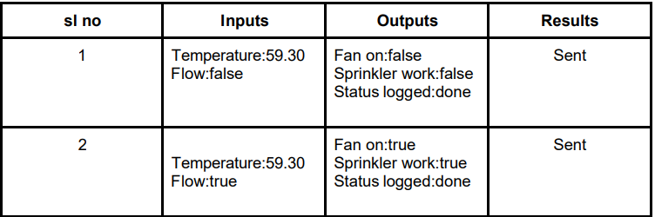

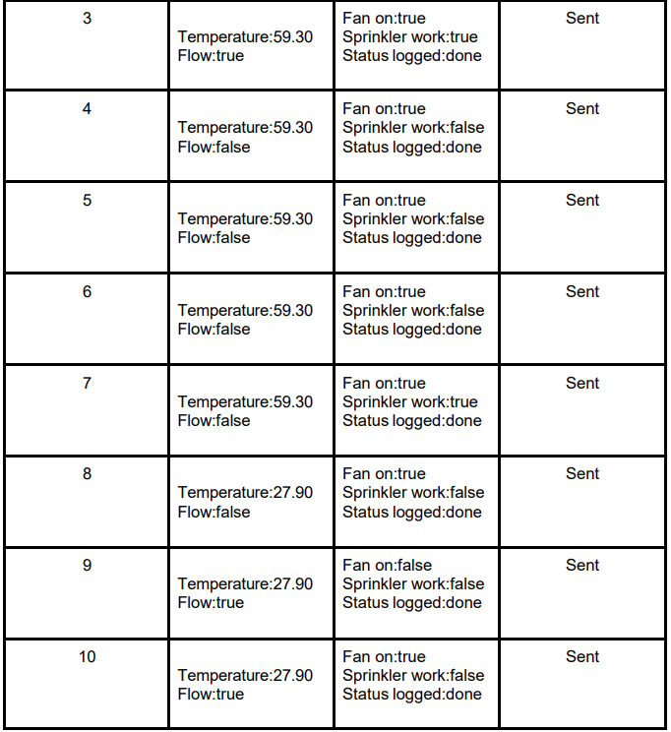

8.2 User Acceptance Testing

You must test smoke detectors and smoke alarms in place to ensure smoke entry into the sensing chamber and to verify an alarm response. You may test with smoke or listed aerosol,

acceptable to the manufacturer of the smoke detector or smoke alarm and identified in the

manufacturer's published instructions.

**9. RESULTS**

We have successfully used to built a web based UI and integrated all the servies using Node

RED web Application

**10. ADVANTAGES & DISADVANTAGES**

## ADVANTAGES OF INTELLIGENT FIRE ALARM SYSTEM:

* Cost effective for larger applications.
* The location of a fire condition is detected and recorded at each individual device, identifying exactly where the fire is occurring. This will improve response time for emergency responders.
* Lower ongoing service cost, because when a device goes into trouble (i.e. needs cleaning, repair or replacement), the panel will tell you the exact location of the device needing service.
* Online capabilities: New intelligent panels have the capability to provide detailed online notification of alarm/trouble/supervisory events.

## DISADVANTAGES OF ADDRESSABLE FIRE ALARM SYSTEM:

* Cost, not as competitively priced for smaller applications.
* Typically with an intelligent panel, your peripheral devices (i.e. [smoke detectors](https://www.orrprotection.com/detection/spot-smoke), etc…)  tend to be more expensive than [conventional devices](https://www.orrprotection.com/fire-alarm/conventional).
* This panel is computer like and at times there maybe issues caused by the firmware (panel software).  However, this is not common and the advantages of intelligent panel far outweigh any of these firmware issues.

**11. CONCLUSION**

The primary advantage of a home fire alarm

system is increased reliability and the ability to place

alarms and bells exactly where needed. However, the

reason most people have them is that they wanted a

burglar alarm system and the cost of adding fire

alarm features to a residential burglary system is

relatively small.

Another advantage is that they are the only

way to obtain remote monitoring services. This

becomes important in cases where family members

may not be capable of escaping from a fire without

assistance. For example, if you have an older or

physically impaired person in your home and a fire

started when no one was home to assist that person,

alarms alone might not be enough to assure their

safety.

Fire wireless sensor platform of hardware

and software design for the entire system

The primary advantage of a home fire alarm

system is increased reliability and the ability to place

alarms and bells exactly where needed. However, the

reason most people have them is that they wanted a

burglar alarm system and the cost of adding fire

alarm features to a residential burglary system is

relatively small.

Another advantage is that they are the only

way to obtain remote monitoring services. This

becomes important in cases where family members

may not be capable of escaping from a fire without

assistance. For example, if you have an older or

physically impaired person in your home and a fire

started when no one was home to assist that person,

alarms alone might not be enough to assure their

safety.

Fire wireless sensor platform of hardware

and software design for the entire system

Fire alarm systems are only effective if they can generate reliable and fast fire alerts with exact location of fire. There is a direct correlation between the amount of damage caused by fire and interventions time in various fire alarm systems. As the time of intervention decreases, the damage also decreases. Hence the most important factor in a fire alarm system is the reaction or response time of fire alarm system, that is, the time between fire detection and extinguishing.  
  
The earliest recorded examples of fire protection can be traced back to the Roman Empire and the catastrophic fires that started in Rome. As a result, Emperor Neron has adopted regulations that required fireproof material for walls and buildings restoration to be used. The second recorded case of adopting fire protection regulations occurred in the year 1666, after the Great fire of London, which destroyed more than 80% of the city. The fire of London spurred interest in the development of the first equipment for fire suppression in the form of hand pumps and fire hydrant installation for water supply.

The primary advantage of a home fire alarm

system is increased reliability and the ability to place

alarms and bells exactly where needed. However, the

reason most people have them is that they wanted a

burglar alarm system and the cost of adding fire

alarm features to a residential burglary system is

relatively small.

Another advantage is that they are the only

way to obtain remote monitoring services. This

becomes important in cases where family members

may not be capable of escaping from a fire without

assistance. For example, if you have an older or

physically impaired person in your home and a fire

started when no one was home to assist that person,

alarms alone might not be enough to assure their

safety.

Fire wireless sensor platform of hardware

and software design for the entire syste

**12. FUTURE SCOPE**

The development of advanced natural fibre composites for construction could play a key role in the transition of an oil-based economy towards a bio-based economy. This chapter first looks at the future scope for the development and uses of advanced natural fibre composites and then goes on to discuss the challenges that relevant industries, both composite manufacturing and construction sectors, have yet to overcome for successful outcomes. The chapter finally investigates the new technologies and potential development of intelligent natural fibre composites for not only application with traditional materials but also specific high value-added applications.

**13. APPENDIX**

**Source Code**

**GitHub & Project and demo link**

**https://github.com/IBM-EPBL/IBM-Project-33492-1660221879.git**